SUPPLY

Supply refers to the amounts of product that producers are willing to sell under various conditions during a given period. The amount of a product that firms are able and willing to offer for sale is called the quantity supplied. Supply is a desired flow: how much firms are willing to sell per period firms are willing to sell per period of time, not how much they actually sell.

Supply schedule and supply curve:
Supply schedule is a table showing the different quantity of a good that producers are willing and able to supply at various prices over a given time period. A supply schedule can be for an individual producer or group of produces, or for all producers.

Supply function:
An equation which shoes the mathematical relationship between the quantity supplied of commodity and the values of the various determinants of supply. The quantity of a commodity that a single producer is willing to sell over a specific time period is a function of price and is expressed as
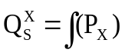 (Ceteris paribus)
Where
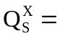 Quantity supplied X (X = any commodity)
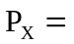 Price of X
This is the simplest form of representing the supply function. Here other factors that influence supply are kept constant. We can write the supply function in a complex way by considering other factors that influence supply. i.e
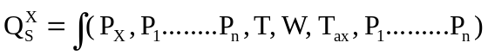
Here
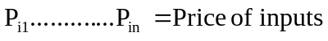
T = Technology
T_{ax} = Taxation and Subsidy
In order to get a producers supply schedule and supply curve of a but price commodity, we Keep all the factors constants while varying the price of the commodity. We get individual producer’s supply schedule and supply curve.
Suppose that a single producer’s supply function for commodity X is
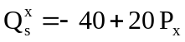 (Ceteris Paribus)
By substituting various relevant price of X into this supply function we get producers supply schedule. as shown in table below.

Supply Schedule:

Px | 6 | 5 | 4 | 3 | 2
Qx | 80 | 60 | 40 | 20 | 0

plotting each point of values from the Supply Schedule on graph and joining the resulting points we get the producers supply carve on shown below

6
5
4
3
2
1
0
.
20 40 60 80
.
.
.
.
P_{x}($)
S_{x}
QS_{x}

the higher the price, the greater will be the quantity of a commodity that will be supplied a producer and vice versa . The relationship between price and quantity Supplied is direct and positive.

Law of supply:

The general relationship between price and supply is, when the price of a good rises, the quantity supplied will also rises. There are three reasons for this
- As firms supply more, they are likely to find that beyond a certain level of output, cost rise more and more rapidly. That is why they are interested to supply more at higher prices.
- The higher the price of the good, the more profitable it becomes to produce, Firms will thus be encouraged to produce more of it by switching from producing less profitable goods.
- Given time, if the price of a good remains high, new producers will be encouraged to set up in production. Total market supply thus rises.

The law of supply states that, other things being equal, the quantity supplied varies directly with the price of the commodity. When price rises, the quantity supplied rises, the quantity supplied rises and when the price falls the quantity supplied also falls. Other things being equal refer to the factors that influence the market supply of a commodity. All these factors are assumed to be constant.
The law of supply is explained with the help of a schedule and a curve. A supply schedule is a statement of the various quantities of a given commodity offered for sale at various prices per unit of time. The following table shows a hypothetical supply schedule for apples.

Supply schedule for apples:

Reference letter | Price in Tk per Kg | Quantity supplied in kg per month
A | 50 | 400
B | 40 | 300
C | 30 | 200
D | 20 | 100
E | 10 | 50

If we depict this schedule on a diagram we have a supply curve as shown in figure below. The supply curve has a positive slope. It moves upward to the right price is measured on the vertical axis and quantity supplied on the horizontal axis. At price 30 Tk per kg quantity supplied is 200 kg per month.

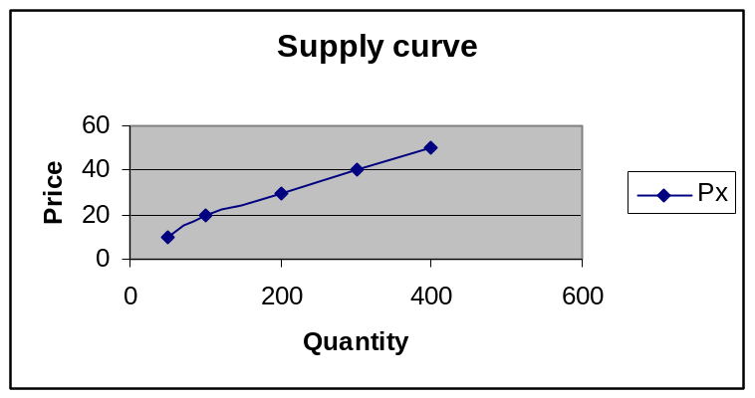

Determinants of supply:

FACTORS INFLUENCING SUPPLY:

(i) The supply of a commodity depends upon the goals of firms: If producers of some commodity want to sell as much as possible, even if it costs them some profits to do so more will be sold of that commodity than if they wanted to make maximum profits. If producers are reluctant to take risks we expect small production of any good the production of which is risky. In elementary economic theory we assume the goal of the firm is to make as much profit as is possible.

(ii) The supply of a commodity depends upon the price of that commodity: Ceteris paribus, the higher the price of the commodity the more profitable will it be to make the commodity. We expect, therefore, that the higher the price, the greater will be the quantity supplied.
(iii) The supply of a commodity depends upon the prices of all other commodities: Generally, an increase in the price of other commodities will make production of the commodity whose price does not rise relatively, less attractive than it was previously. We thus expect that, ceteris paribus, the supply of one commodity will fall as the prices of other commodities rise.
(iv) The Supply of a commodity depends upon the prices of factors or production: A rise in the price of one factor of production will cause a large increase in the costs of making those goods that use a great deal of that factor, and only small increase in the costs of producing those commodities that use a small amount of the factor. For example, a rise in the price of land will have a large effect on the costs of producing wheat and only a very small effect on producing motor vehicles. Thus a change in the price of one factor of production will cause changes in the relative profitability of different lines of production and this will cause change in the supplies of different commodities.
(v) The supply of a commodity depends upon the state of technology: The enormous increase in production per worker that has been going on in industrial societies for about 200 years is very largely due to improved methods of production. Those in turn have been heavily influenced by the advance of science. Discoveries in chemistry have led to lower costs of production of well-established products, like paints, and to a large variety of a new products made of plasticity’s and synthetic fibers. The new electronics industry rests upon transistors and other tiny devices that are revolutionizing production in television, high-fidelity equipment, computers and guidance control systems. Atomic energy may one day be used to build canals and to extract fresh water from the sea. At any time what is produced and how it is produced depend upon what is known. Over time, knowledge changes and so do the supplies of individual commodities.

vi) Transport and communication:

vii) Tax and Subsidy:

viii) Time:

ix) Weather:

x) Export and Import:

xi) Number of producers:
xii) Social factors:
SHIFTS IN THE SINGLE PRODUCER’S SUPPLY CURVE

When the factors that we kept constant in defining a supply schedule and a supply curve (cet. par.) change, the entire supply curve shifts. This is referred to as a change or shift in supply and must be clearly distinguished from a change in the quantity supplied (which is a movement along the same supply curve).
Table 1.2 gives two supply schedules of a producer of commodity X. The first of these two supply schedules (QS_{x}) is a normal supply schedule. The second (QS_{x}©) resulted from an increase in the prices of the inputs necessary to produce commodity X (cet. par.).
(a) Now we plot the points of the two supply schedules on the same set of axes and get the two supply curves.
(b) What would happen if the price of X rose from $3 to $5 before the shift in supply?
(c) What quantity of commodity X will the producer place on the market at the price of $3 before and after the supply curve shifted up?
(d) What happens if at the same time the producer’s supply of X decreases, the price of X rises from $3 to $5?

Table 1.2

P_{x}($) | 6 | 5 | 4 | 3 | 2 | 1
QS_{x} | 42 | 40 | 36 | 30 | 20 | 0
QS_{x} © | 22 | 20 | 16 | 10 | 0 | 0

(a)

.
.
.
.
.
.
P_{x}($)
Q_{x}
A
C
D
.
.
S_{x}©
S_{x}
.
B
6
5
4
3
2
1
0
.
.

10 20 30 40 50

Fig. 1.2

b) When the price of X rises from $3 to $5, the quantity of X supplied by the producer increases from 30 to 40 units per time period. (This is a movement along S_{x} in an upward direction, from point A to point B in the figure.)

c) The upward shift in the entire supply curve from S_{x} to S_{x}© is referred to as a decrease in supply. At the unchanged price of $3, the producer will now (i.e., after the shift) supply 10 units of X rather than 30 (i.e., the producer goes from point A to Point C)
d) When both the producer’s supply of X decreases and the price of X rises form $3 to $5, the producer will place on the market 10 units less than before these changes occurred (i.e., the producer goes from point A to point D).

If there is an improvement in technology: (so that the producer’s costs of production fall), the supply curve shifts downward. This downward shift is referred to as an increase in supply. It means that at the same price for the commodity, the producer offers more of it for sale per time period. It will be clear from the following analysis.
Suppose that as a result of an improvement in technology, the producer’s supply function becomes QS_{x}© = -10 +20P_{x} (as opposed to QS_{x} = - 40 + 20P_{x} in previous example ).
(a) Now we derive this producer’s new supply schedule.

(b) On one set of axes, draw this producer’s supply curves before and after the improvement in technology.

(c) How much of commodity X does this producer supply at the price of $4 before and after the improvement in technology?
(a)
Table 1.3
P_{x}($) | 6 | 4 | 2 | .5
QS_{x}© | 110 | 70 | 30 | 0

6
5
4
3
2
1
0
40 70 110
P_{x}($)
S_{x}
QS_{x}
S_{x}©
.
.
.
.
.
.
.
.
.
.
.
(b)

Fig.1.18

(C) Before the supply curve increased (Shifted down), the producer offered for sale 40 units of X at the price of $4. After the improvement in technology, the producer is willing to offer 70 units of X at the same commodity price of $4.

